**Contents:**

1. Abstract

2. Introduction

3. Methodology

4. Conclusion

1. **Abstract**

The aim to design and develop this project is to produce a tourist guide for Nagpur city, which can efficiently guides the tourist who visits Nagpur city. Due to its natural beauty many domestic and international tourist visits every year. The tourist guide can be use in place of professional guide due to many reasons like reduce cost of guide, get more accurate information needed for decision making, giving weather and social networking services.

The tourists can use this guide for different purposes like get all tourist places in Nagpur City and other information like, Address, Url, Email, Contact etc.

1. **Introduction**

The aim to design and develop the project is to produce a tourist guide for Nagpur city to facilitate domestic and international tourists. Due to unavailability of proper tourist guide tourist face many problems. As traditional practice when a tourist visits Nagpur they have to engage professional tourist guides. The guides provide information about the city. We have to spend handsome amount of money to get such services of a professional guide. It is expensive for most of the tourists. Mostly guides are not professional because they working part time in summer season as guide and in winter they used to work in some other fields. So sometimes the guide also could not give proper information to the travellers because of human nature they cannot remembers facts and figures which is required for decision making like, information of that place and historical importance etc.

Purpose Of Smart City(Nagpur) Project are as follows:

• Reliable Guide: The tourist could use printed information about that places and hire a guide but it is not fulfills the tourist needs. By using smartphones features such as Internet we can use reliable and interactive address of the area. The application provides reliable and accurate data which helps in decision making.

• Profit: The smart city application is so simple to handle. So, anybody can handle it very easily.

1. **Methodology**

I have developed the Smart City (Nagpur) java project which is built on Eclipse. If we have to run this project first of all we have to go to the eclipse and run it on console. After running this program list of facilities available in the Nagpur city will appear in the console screen from their we have to select an option.

After selecting a particular option we will see the information related to that category where we will see the list of selected categories places ex. If we select a spot which is Attraction in that many attractive spots will appear and after that we can choose a spot where we want to go and we will be able to see the details of that spot, and the same functionality will work for other categories

**FLOW CHART OF SMART CITY PROJECT**

**START**

**ALL FACILITY LIST**

**SUB FACILITY LIST**

**DETAILS OF SUB FACILITIES**

**WANT TO VISIT SOMEWHERE ELSE?**

**END**

**YES**

**NO**

1. I first created a class for showing all the facilities which are available in the Nagpur city.

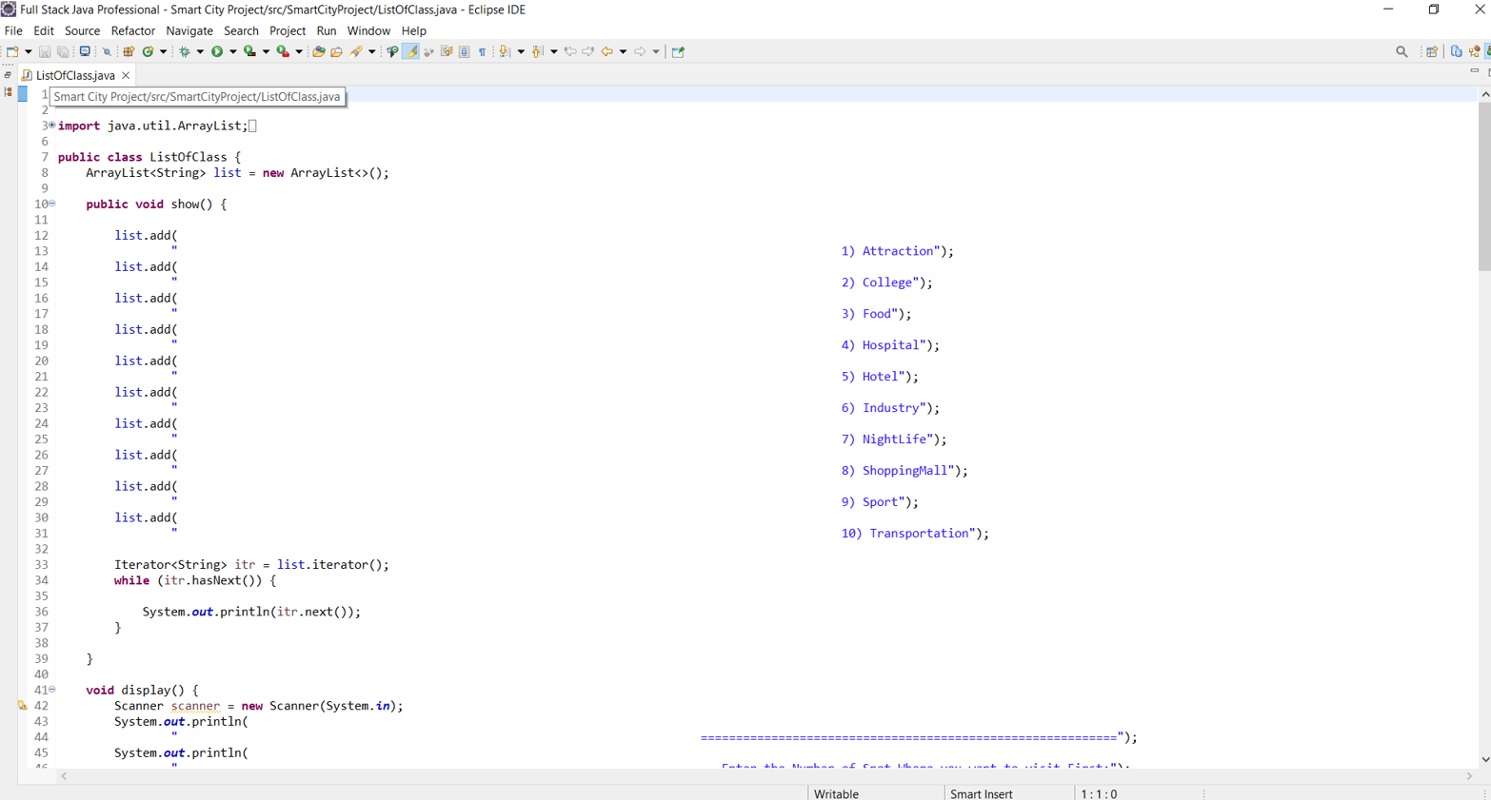

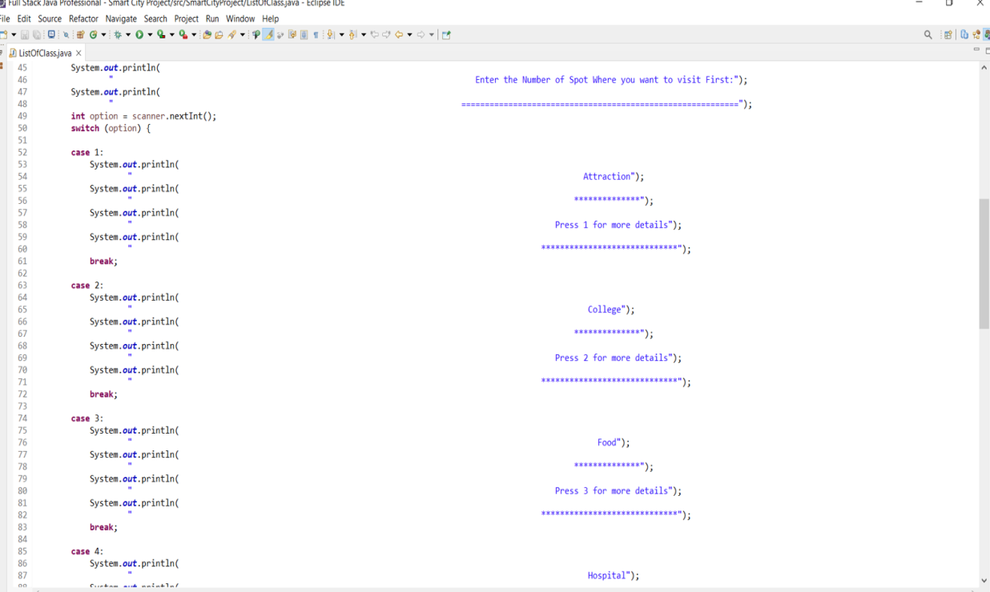

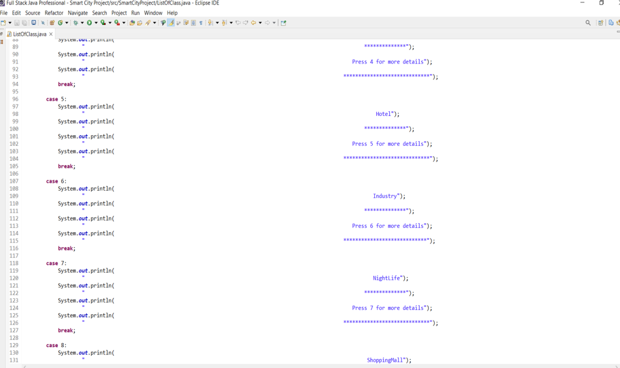

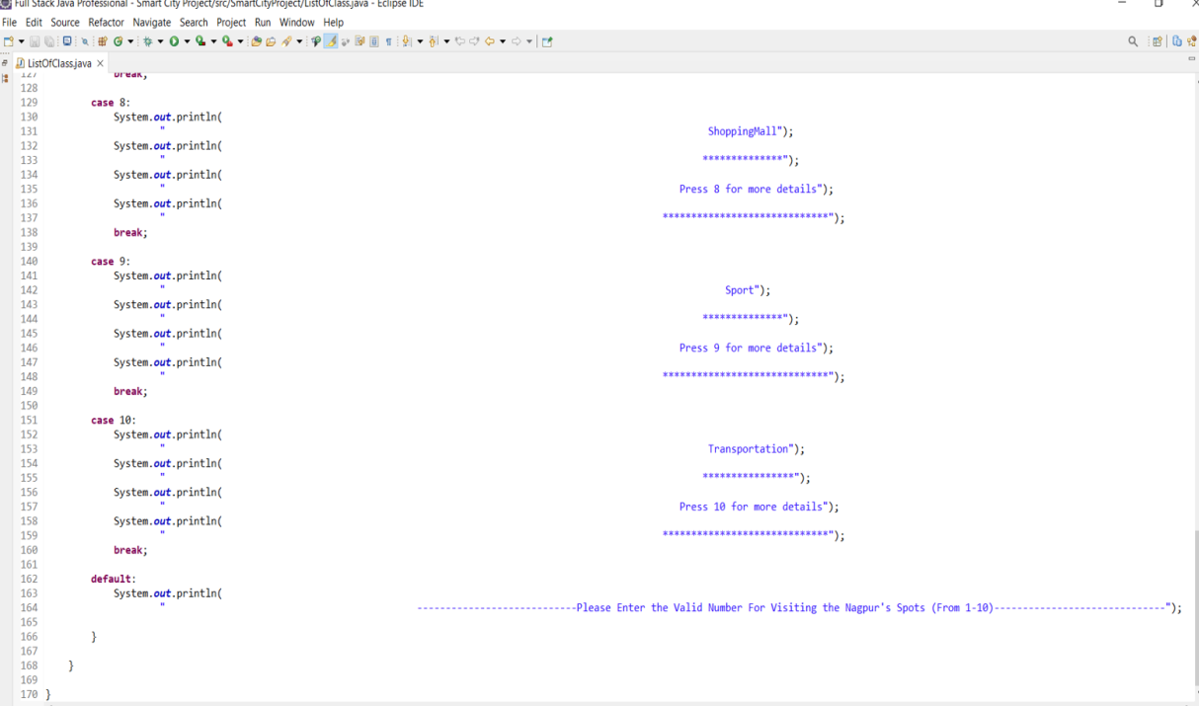

1. After I created a main class for the calling all the methods which are belongs to the POJO classes. And here, From the class ListOfClass the first show() method is called and the output will be given below:-

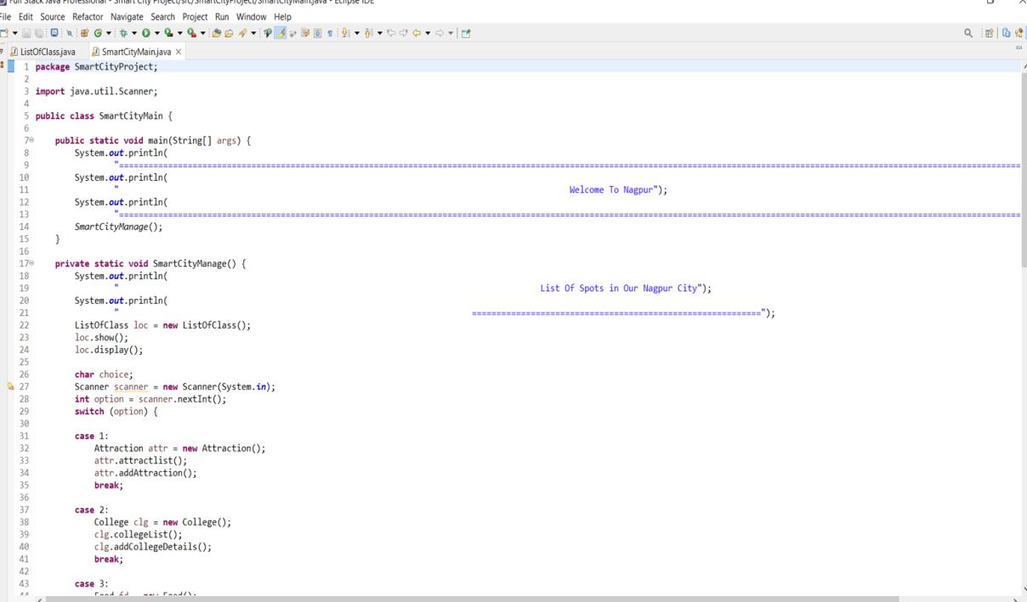

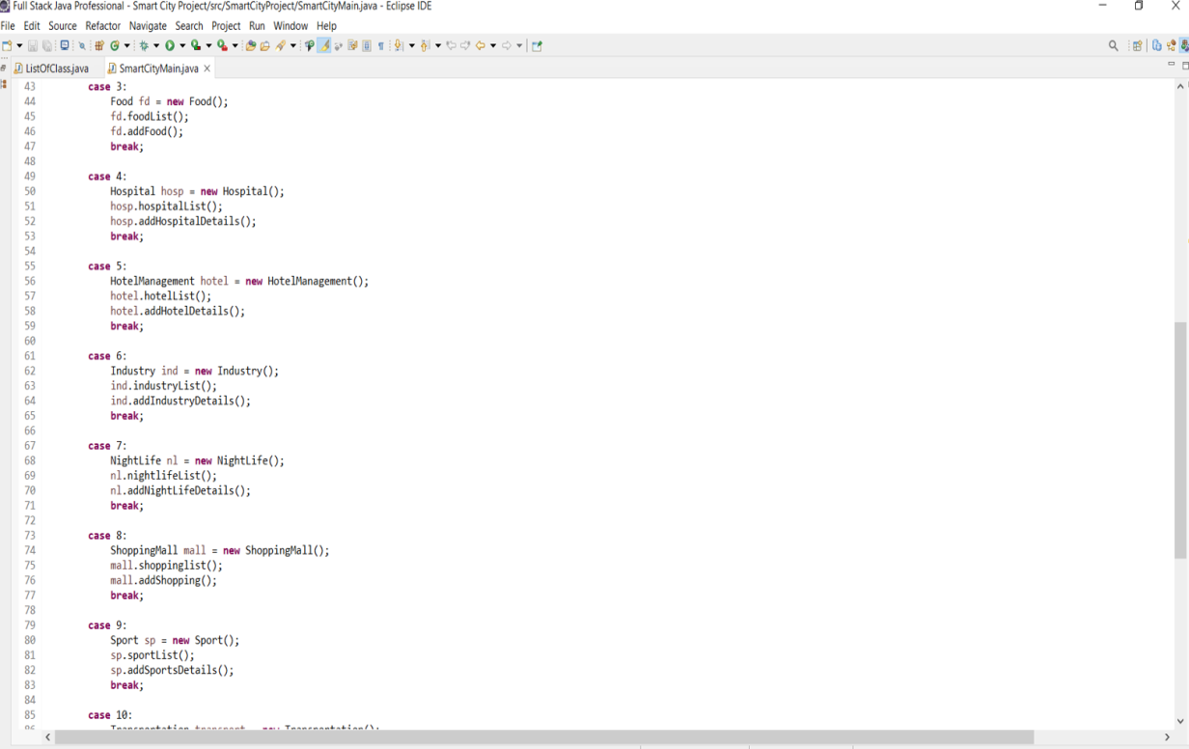

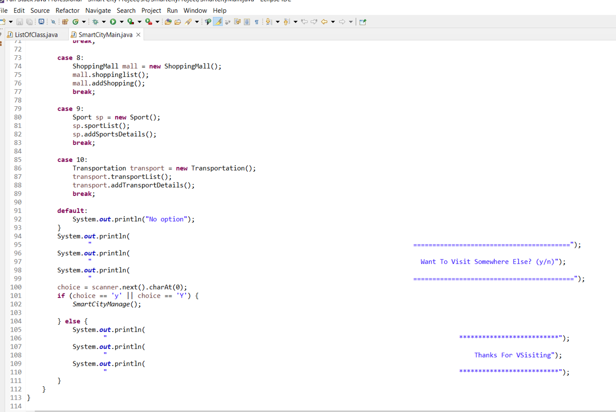

1. And here is the output of the first ListOfClass class of show() method. List of facilities which are available in the Nagpur. If we select any one of the Spot from the list of facilities we will get any one spot using the second method which is display() method

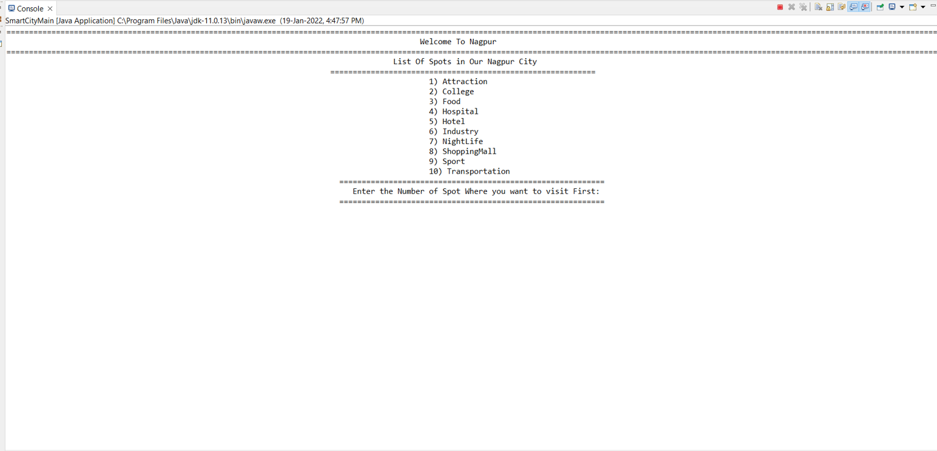

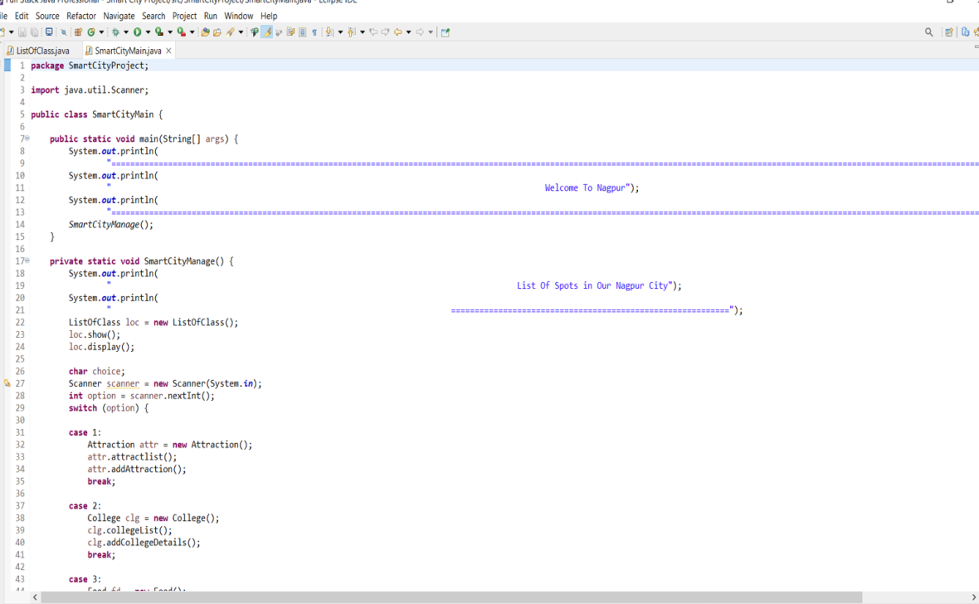

1. Here we click on the no. 1 so we get the next step is Attraction Spot using the display() method

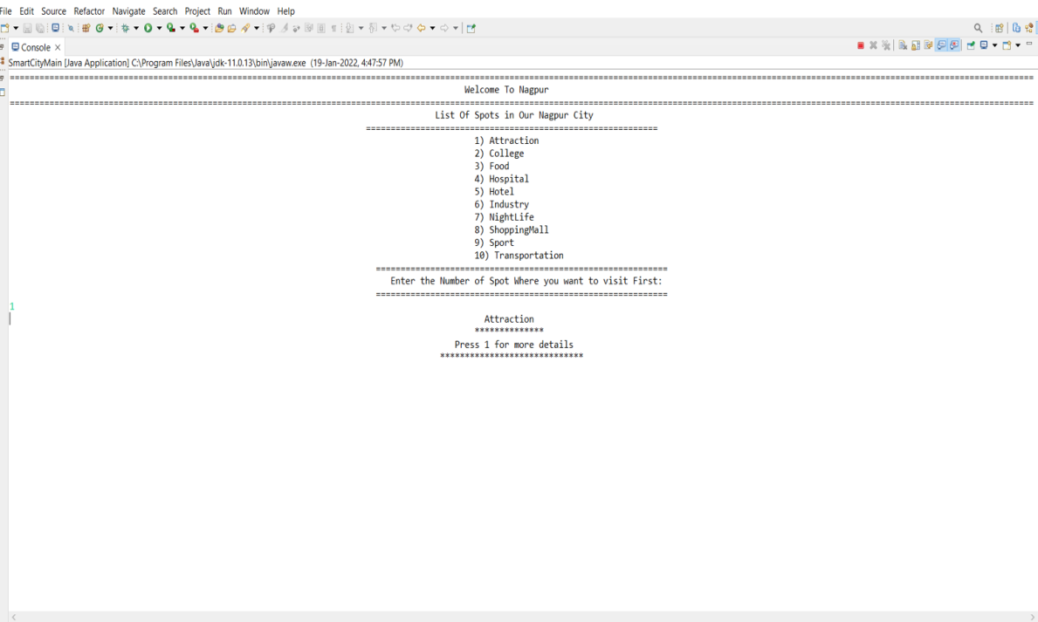

1. After that If we again press the no.1 for more details of Attraction Spots then we will get the all sub spots of the Attraction Spot by using the switch() cases and in the switch() case there is a method for attraction which is attractList() method and because of this method we will able to see the list of Attraction places

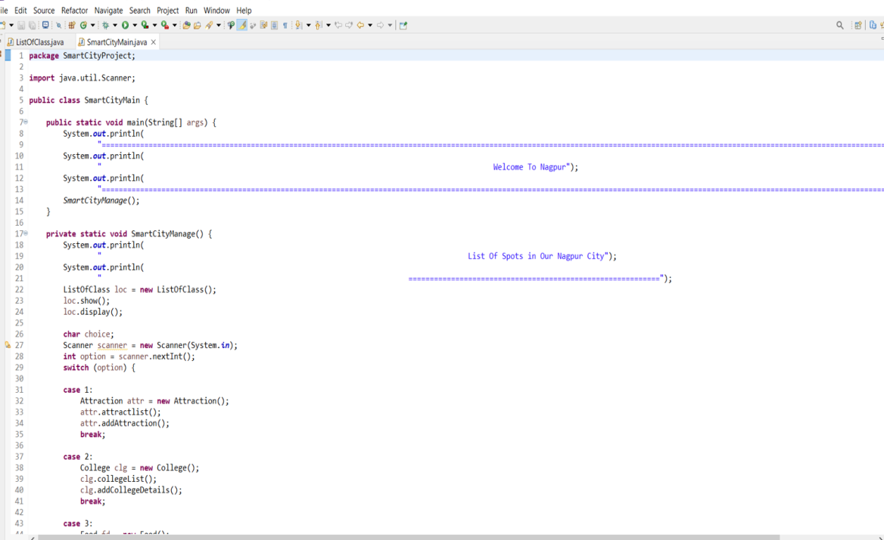

1. And using the attractList() method we will get the list of all sub Attractive Spots. And after that if we want to visit the particular place or spot then we can choose the number given in the list and we will be able to see the whole details of that particular spot like address, contact number, email address, and so on.

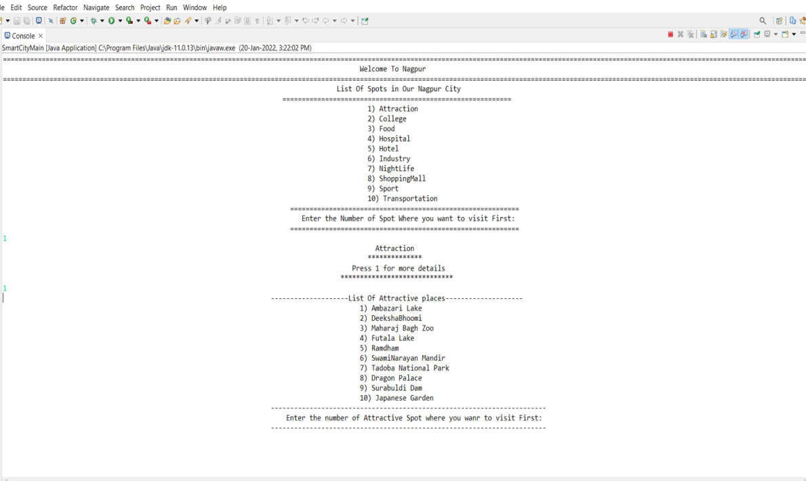

1. Using the another method which is given in the class Attraction is addAttraction() method by using this method we will be able to see the whole details of that particular Attractive Spot.

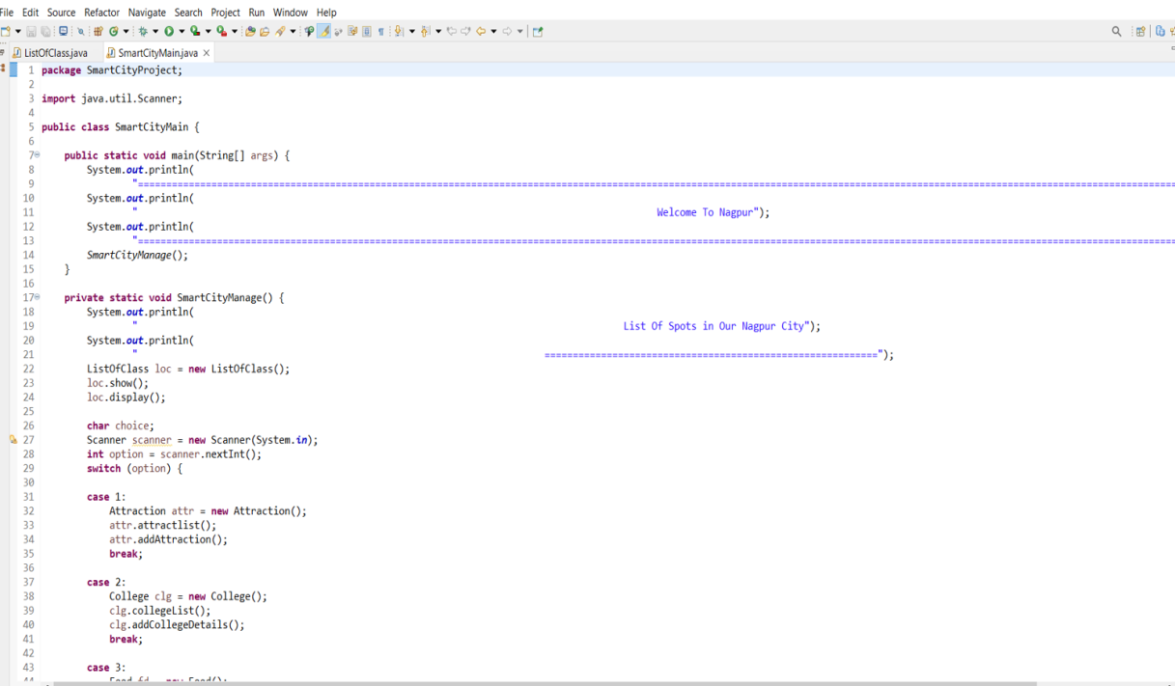

1. And the output will be like this_

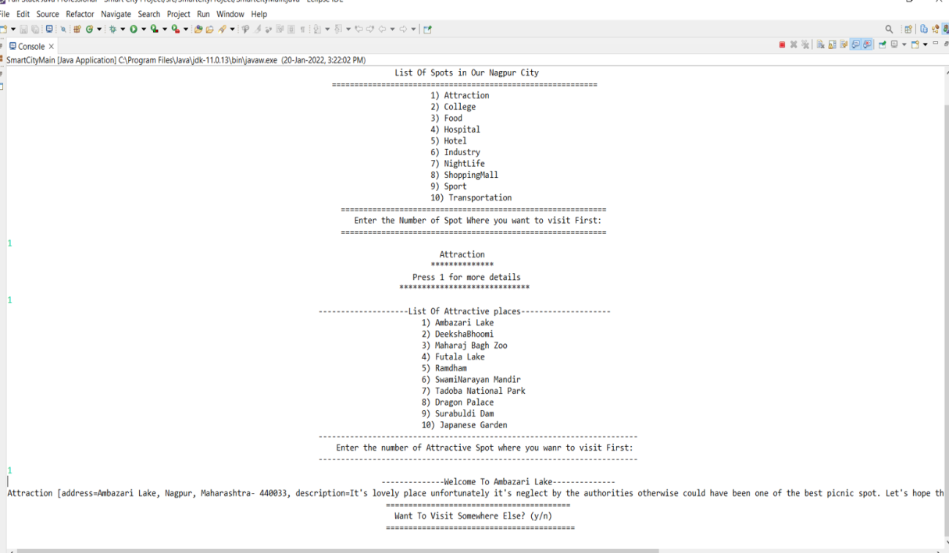

1. This process we will repeated for all the Classes whatever Spots tourist wants to visit he/she can visit the places again and again he/she will get the all information regarding the tourist spots. And if he/ she don’t want to visit anywhere he / she can go (y/n) option he/she will be able to exit the application means if tourist press the ‘n’ key then he/ she will automatically exit. And the output is given below:-

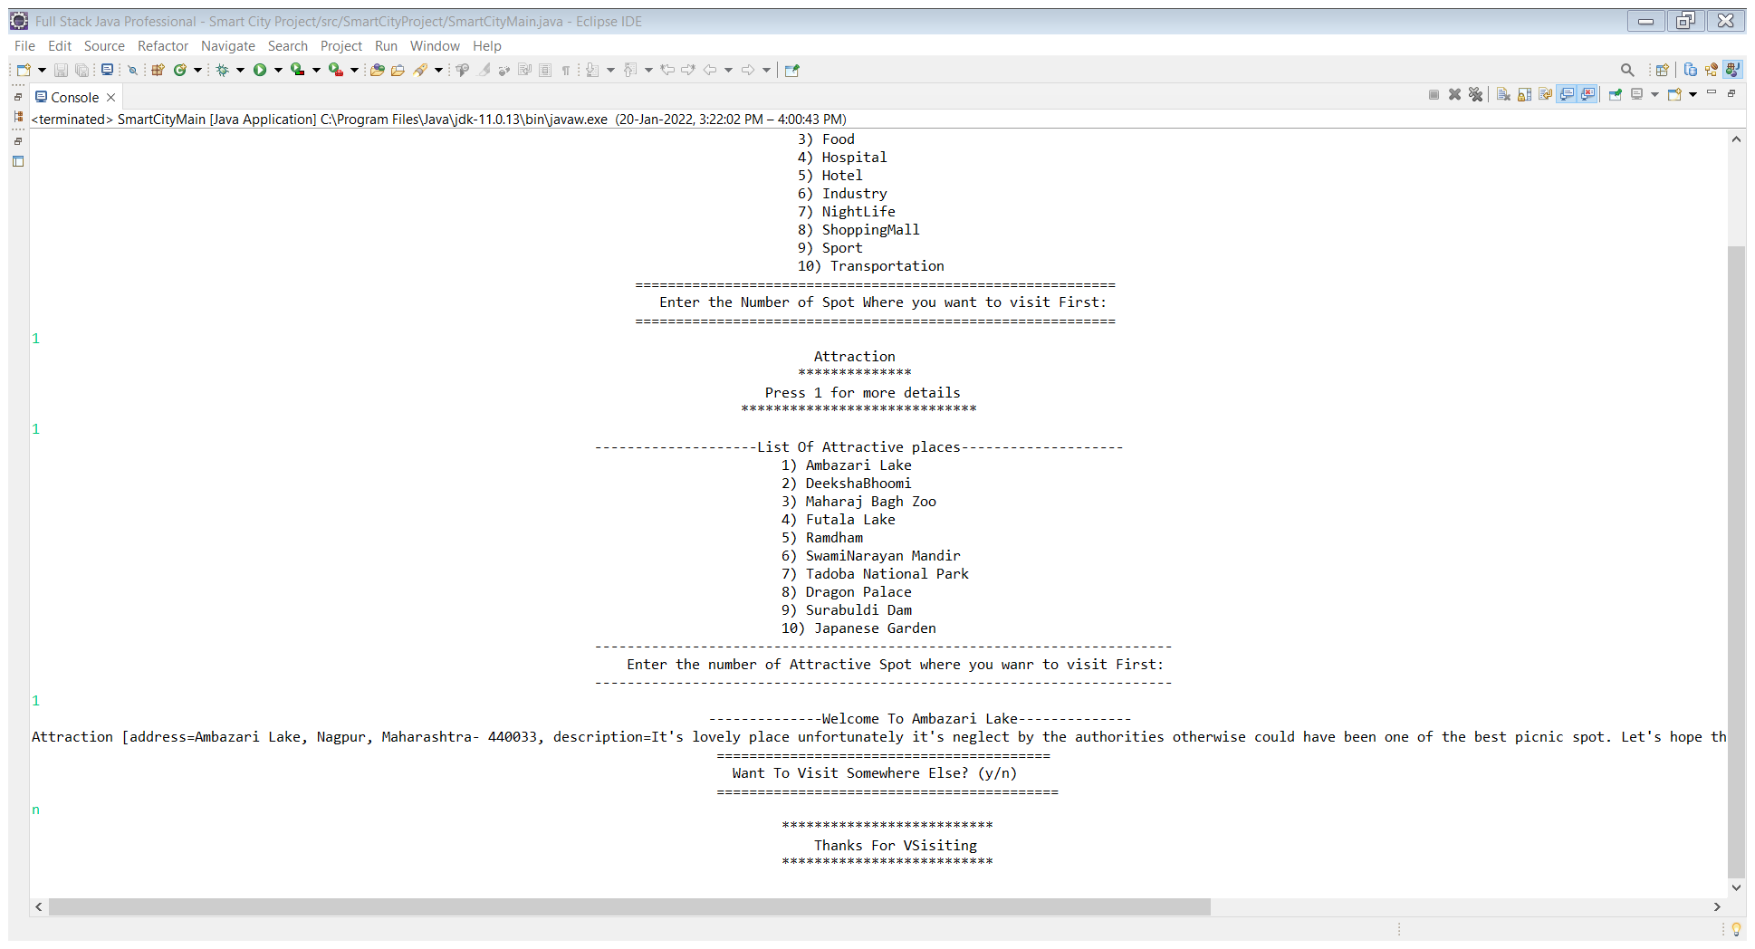

1. **Conclusion**

The Smart City Application is developed using core Java and Data Structure fully meets the objectives of the Application for which it has been developed. The system has reached a steady state where all bugs have been eliminated. The system solves the problem. It was intended to solve as requirement specification.

THANK YOU